# Technical Design Document: Programming Exercise CSV

# Name: Lucas Korzeniewski
# Date: July 5, 2026
# Program Description: This assignment consists of two Python programs that use the csv module. The first program allows an instructor to enter student names and three exam grades, then saves the information to a file named grades.csv. The second program reads the data from grades.csv and displays it in a table.
## Function: create_grades_file()
Prompts the instructor to enter student information and exam grades, then writes the data to grades.csv.
Parameters:
none
Variables:
student_count (integer): Stores the number of students to enter.
first_name (string): Stores the student's first name.
last_name (string): Stores the student's last name.
exam_1 (integer): Stores the student's first exam grade.
exam_2 (integer): Stores the student's second exam grade.
exam_3 (integer): Stores the student's third exam grade.
csv_file (file object): Represents the opened CSV file.
writer (csv.writer object): Writes data to the CSV file.
Logic:
- Ask the instructor how many students they want to enter.
- Open grades.csv for writing.
- Write the header row to the file.
- Repeat for each student:
  - Enter the student's first name.
  - Enter the student's last name.
  - Enter the three exam grades.
  - Write the student's information to the file.
- Close the file automatically using the with statement.
- Display a confirmation message.
Return:
None

## Function: display_grades()
Reads the student records from grades.csv and displays them in a table.
Parameters:
None
Variables:
csv_file (file object): Represents the opened CSV file.
reader (csv.reader object): Reads data from the CSV file.
header (list): Stores the column headings.
row (list): Stores one student's record while reading the file.
Logic:
- Open grades.csv for reading.
- Read the header row.
- Display the column headings.
- Display a separator line.
- Read each student record.
- Display each record in tabular format.
- Close the file automatically using the with statement.
Return:
None
## Function: main()
Calls the main function for the program being executed.
Parameters:
None
Variables:
None
Logic:
Call the appropriate function (create_grades_file() or display_grades()).
Return:
None

#Link to your repository: https://github.com/lucask333?tab=repositories
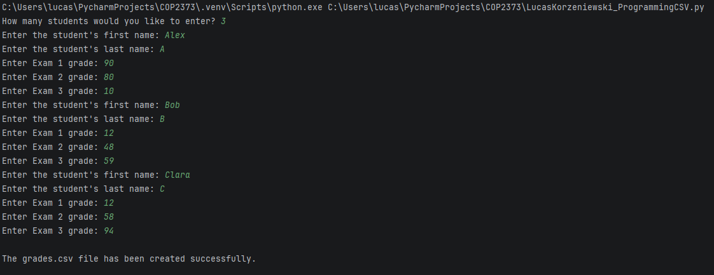
Output Screenshot: (make sure big enough so I can see)
